PURE-XML
Functional Specification
<<V1.16>>

Updates
Version | Date | Sections changed | Description | Author(s)
0.1 | 09/09/2011 | All | Document creation | KPA
0.2 | 14/09/2011 | All | Object-independent versioning and search functions (removed Semantic Version and Linguistic Correction objects).  ACEs only with user group/roles. | KPA
0.3 | 27/09/2011 | All | Usage of the Logical Unit as main object for the IRO model | KPA
0.4 | 21/10/2011 | All | Comments from G. Alari | KPA
0.5 | 03/11/2011 | All | Comments from F. Hands.  Update based on the decisions taken in the meeting held on 27/10/2011  Introduction of the "Content-Type" object for the handling of content metadata. | KPA
0.6 | 16/11/2011 | 14 | Java API definition | KPA
0.7 | 01/12/2011 | 6  13.2 | Content-Type properties and XML metadata separation.  Statistics | KPA
0.8 | 07/12/2011 | 12 | Notifications support
0.9 | 19/12/2011 |  | Integration of comments | KPA
1.0 | 20/12/2011 |  | Validated version
1.1 | 16/02/2012 | 14 | Added missing methods in Java API:  Repository.delete  Repository.deleteNodeByURI  AccessControlManager AccessGroup methods | PPA
1.2 | 28/03/2012 | 3.1, 4.4.1  5.1.8  12.2 | Added support for language codes that are EP (CODICT) extensions.  Output set to boolean flag.  Updated specification for the notifications following clarifications during the technical specification preparation. | KPA
1.3 | 02/05/2012 | 4.1.1, 5.1.9, 5.2.11, 5.3.3  5.1.2, 5.1.3 and all other paragraphs that contained the old names.  12.1  14.1 | Property "ParentURI" removed. Move operations do not have to update that property anymore.  Methods "getProperties" and "get/setProperty" renamed to "getSystemProperties" and "get/setSystemProperty".  Clarification (footnote) concerning the "Comment" field.  Update the Java API to reflect the above changes.  Changed the Changelog functions to return "List" instead of "Array" (27/4/2012). | KPA
1.4 | 08/05/2012 | All  6.1  6.2.3  13.1  14.1 | Replaced "Object ID" with Object in order to avoid misunderstandings with technical implementation IDs.  Removed the logical-level and physical-level XML metadata.  Changed definition for get XMLmetadata  Method getObjectID renamed to getObject  Removed getXMLmetdata from logical and physical levels.  Added method getAllXMLmetadata for XML Renditions.  Added method getAllTags for a given node.
1.5 | 13/07/2012 | 14.1 | Added function Node::getTypeName()  Updated API functions following attached email (but keeping the nodeTypeName parameter as decided in the kick-off meeting)  
1.6 | 16/07/2012 | 4.1.1  14 | Updated with outcomes of the Kick Off Meeting of 12/07/2012 and previous decisions.  Modified the Java API signatures to match current implementations. | PPA
1.7 | 01/10/2012 | 6.1.1 | See attached email  
1.8 | 16/11/2012 | 3.1.1  4.1.1  4.3.1  5.2.1, 5.2.5, 5.5.1, 5.5.2  4.4  4.5  5.3.2  6.1  6.1.5  12.4.2  14.1  9.2, 13.1 | Update following first delivery of PURE-XML phase 1  Logical units can always contain physical units.  "Name" attribute cannot contain special characters.  The updating of the "OrderID" attribute is implementation specific. (no specific need for synchronous updating).  Clarification of the unique constraint for versionable objects.  Logical unit type shall be a read-only property after the node creation.  File size shall have a configurable upper limit.  Physical Units cannot be moved to Logical Units of different "Content-Type".  XML Renditions cannot be moved to Physical Units of different "Content-Type"  Circular links are not allowed.  Unique constraint must apply for the content-type property names  Added method Delete XML Metadata  Parallerl execution of the changelog cleanup function is not allowed  Updated methods getRepository and XMLRendition::updateXML  Added methods Node::setSystemProperties and ContentTypeManager::deleteXMLmetadata  Representation of versions in the URI of versionable objects
1.9 | 05/02/2013 | 3.1  13.1, 14.1  11.2, 12.3  14.1 | Changed starting value for the versions (from 0.1 to 1.0)  Added function getObjectbyUBI  Removed "notify" access right (merged under "admin").  Added support for basic transactions. Added Java API methods Repository::startTransaction and Repository::endTransaction.
1.10 | 08/02/2013 | 4.5, 5.5,  14.1 | Support for multiple renditions
1.11 | 12/03/2013 | 4.1.1, 4.3.1, 4.4.1, 4.5.1, 4.6.1  12.1, 12.4.1  14.1  Annex II | UBI is a property only for the business-related objects.  Added changelog search by UBI. Clarified search by URI.  Added API method updateTagDescription  Updated Permissions Table
1.12 | 14/03/2013 | 4.1.1, 8.2.1, 12.4.1, 14.1 , 5.1.1, 9.1.3, 9.1.4, 9.1.5, 7.1.1 | Added phase 2 Iteration 1 changes | PPA
1.13 | 01/07/2013 | 5.1.7  6.1  7.1,  7.2  8.1  9.2  11.3  12.1  12.4.1  14.1 | Added new exception type  Added limitation on the content type name  Added limitation on the relationship name, modified the definition of “Define Relationship” to allow update of existing relationships  Updated the input parameters of Create Relationship, Delete relationship to include the target object  Added limitation on the tag name  Added clarifications regarding the version identifier existing in the URI of versionable objects  Added exception cases in Define Group  Updated the Event object to include the related object ID  Updated the changelog search to include search using an object ID  Updated the API with new methods UBIexists, URIexists, getOrder, setOrder, getCreator, getChangelogById. Renamed getOwner to getLockOwner | PPA
1.14 | 07/08/2013, 28/08/2013 | 4.5.1, 5.5, 7.2.1, 12.1, 5, 7.2.2 | Exception is added for relate method.  Content change notification event is removed.  Exceptions added for delete and move operations.  Delete relationship remove redundant condition. | KPA, PPA
1.15 | 24/09/2013 | 4.1.1  5.1.3  10.3.1  14.1 | Added Object type in the system properties  Added PWC renaming restriction  Removed search parameters content-type and IRO level since they are included in the search criteria  Added isLatest() method | PPA
1.16 |  | 6.1, 10.1.2 | XML metadata support for Text Path expressions | PPA
Referenced documents
ID | Document Title | Description | Version
R1 | Technical Consolidation of IRO Information Models, October 2008 | Technical analysis and definition of the IRO information model and its versioning schema.
R2 | AT4AM & DST Service Description | Content management web services and domain objects that are required by the AT4AM and DST projects. | v1.1
R3 | PURE-XML Needs Study | Description of the initial needs for the project. | v0.3
R4 | Minutes of the meeting held on 27/10/2011 |  | v0.2

Table of Content
1. Glossary 10
2. INTRODUCTION 12
2.1. Purpose 12
2.2. Components 12
2.2.1. Client Applications 13
2.3. Constraints 13
3. Object Model 14
3.1. PURE-XML Model 15
3.1.1. Repository Objects 17
4. Repository Object Type Definitions 21
4.1. Folder 21
4.1.1. System Properties 21
4.2. File 24
4.2.1. System Properties 24
4.3. Logical Unit 24
4.3.1. System Properties 24
4.4. Physical Unit 25
4.4.1. System Properties 25
4.5. Rendition 25
4.5.1. System Properties 26
4.5.2. XML Rendition 26
4.6. Media 26
4.6.1. System Properties 27
5. Object-level CRUD functions 28
5.1. Folder 28
5.1.1. Create 28
5.1.2. Get System Properties 28
5.1.3. Update System Properties 28
5.1.4. Delete 29
5.1.5. Lock 29
5.1.6. Unlock 29
5.1.7. Link 29
5.1.8. Unlink 30
5.1.9. Move 30
5.1.10. Get Children 30
5.2. File 32
5.2.1. Create 32
5.2.2. Get System Properties 32
5.2.3. Get Content 32
5.2.4. Update System Properties 32
5.2.5. Update Content 32
5.2.6. Delete 33
5.2.7. Lock 33
5.2.8. Unlock 33
5.2.9. Link 33
5.2.10. Unlink 33
5.2.11. Move 33
5.3. Logical Unit 35
5.3.1. Create 35
5.3.2. Link 35
5.3.3. Move 36
5.4. Physical Unit 37
5.4.1. Create 37
5.4.2. Get System Properties 37
5.4.3. Update System Properties 37
5.4.4. Delete 37
5.4.5. Lock 37
5.4.6. Unlock 37
5.4.7. Get Children 37
5.5. Rendition 38
5.5.1. Create 38
5.5.2. Update XML Content (for XML Renditions only) 38
5.6. Media 38
6. Content-Types 39
6.1. Content-Type Object 39
6.1.1. Define Content-Type 40
6.1.2. Undefine Content-Type 40
6.1.3. Get Content-Type by Name 40
6.1.4. Get All Content-Types 40
6.1.5. Delete Content-Type XML metadata 41
6.2. Object Functions 41
6.2.1. Get Content-Type Properties 41
6.2.2. Set Content-Type Properties 41
6.2.3. Get XML Metadata 41
6.2.4. Search support 42
7. Relationships 43
7.1. Relationship Object 43
7.1.1. Define Relationship 43
7.1.2. Undefine Relationship 43
7.1.3. Get Relationship by Name 44
7.1.4. Get All Relationships 44
7.2. Object Functions 44
7.2.1. Create Relationship 44
7.2.2. Delete Relationship 44
7.2.3. Get Related Objects 45
7.2.4. Get Source Relationships 45
7.2.5. Get Target Relationships 45
7.2.6. Search for Relationships 45
8. Tagging 46
8.1. Tag Object 46
8.1.1. Define Tag 46
8.1.2. Undefine Tag 46
8.1.3. Get Tag by Name 47
8.1.4. Get All Tags 47
8.2. Object Functions 47
8.2.1. Add Tag 47
8.2.2. Delete Tag 47
8.2.3. Search for Tags 47
9. Versioning 49
9.1. Object functions 50
9.1.1. Get Versions 50
9.1.2. Get Latest 50
9.1.3. CheckOut 51
9.1.4. CheckIn 51
9.1.5. Cancel CheckOut 52
9.2. URI mapping 52
10. Search 54
10.1. Search criteria 54
10.1.1. Properties 54
10.1.2. Full Text 54
10.2. Ordering 55
10.3. Search functions 55
10.3.1. Search 55
11. Access Control 56
11.1. Authentication 56
11.2. Permission Levels 56
11.3. Group definition 57
11.3.1. Define Group 57
11.3.2. Undefine Group 57
11.3.3. Get Group by Name 57
11.3.4. Get All Groups 57
11.4. Access Control Lists 58
11.4.1. Get ACL 58
11.4.2. Set ACL 58
12. Notifications & Changelog 59
12.1. Event Object 59
12.2. Notifications 60
12.3. Modifications history 60
12.3.1. Get Modifications History 60
12.4. Changelog support functions 60
12.4.1. Changelog search 61
12.4.2. Changelog cleanup 61
13. Miscellaneous support functions 62
13.1. Get Object 62
13.2. Statistics 62
14. PURE-XML API 63
14.1. Java binding 63
15. Management Console 77
Annex I. Use Cases 78
A. Create new Amendment 78
B. Edit existing Amendment 79
C. Document Creation 80
Annex II. Permissions Table 81

Glossary

API | Application Programming Interface
ACL | Access Control List (List of ACEs).
ACEs | Access Control Entries. ACL items defining the access rights for a given group or role.
Client | Any Actor (Application or other) that is using PURE-XML services
Content Management System (or CMS) | This is a system, which is responsible for managing the flow of work on documents and files. More specifically, in this case, it is the system responsible for supporting the document based legislative processes of the European Parliament.
Content Repository | The content repository is the part of a CMS, which is responsible for storing the documents and files. It delivers resource based security (each file can have a separate security) and the mechanisms for CRUD + Versioning operations on both content and properties.
CR | Content Repository
CRUD | Create Retrieve Update Delete
Entity (or object) | Something that has a distinct, separate existence, defined from a type configured in the Content Management Repository.
IRO | Information Resource Officer.  Website: http://eicisdw.ep.parl.union.eu/sdw/iro/index.cfm
Logical Chunk | The Logical Chunk is a semantic message on its own. It constitutes a semantic whole and it may be identified as a logical unit (an equivalent to the UDI, but not the UDI as such). See [R1] and the IRO website for more details.
Logical Information Block | The logical information block is a unit of business information and constitutes a semantic whole on its own. It may appear in different documents but it may have a business life of its own. The semantic message is reusable and may be used in many different contexts but it is still understandable on its own. See [R1] and the IRO website for more details.
Logical Document | A logical document is a meta-layer of the content of physical electronic documents (one or more language versions, evolutionary versions or electronic format versions), representing the semantic content of these physical documents. See [R1] and the IRO website for more details.
Metadata (XML) | Metadata within the XML content that are managed only via the content-related functions of the API.
Properties | Metadata of an entity (as defined in the type definition). PURE-XML has two types of properties:  - System properties, which are common for all the objects of the repository.  - Content properties, which are user-defined properties associated to a particular content-type and can be assigned to the IRO repository objects.
PURE-XML | Parliament Unique REpository for XML text production
PWC | Private Working Copy
Relation(ship) | The relation or relationship describes an association between two entities/objects in the content repository. PURE-XML maintains automatically the following relationships:  - Containment: Physical parent-child relationship for the hierarchical structuring of the data.  - Links (References): Logical parent-child relationship for the hierarchical structuring of the data.  - Based-on: Versioning history (relationship between versions of versionable objects  PURE-XML supports also application-defined relationships.
Type (or Type Definition) | Classification identifying one of various types of entities (with properties and allowed relationships) that can exist as distinct separate existence in the Content Repository.  Also called "Type Definition".
UDI | Unique Document Identifier. See IRO Position (15) on UDI Naming Authority
IBID | Unique Information Block Identifier. See IRO Position (29) on Information Block Identification.
UCID | Unique Chunk Identifier
UBI | Unique Business Identifier
URI | Unique Resource Indicator

INTRODUCTION

Purpose
The scope of this document is to define the functional specification of the Parliament Unique Repository for XML text production (PURE-XML). The system shall provide an API which will be the only access point to the content repository for all the e-Parliament applications.
The PURE-XML repository must fully support the IRO model and its versioning schema for the storage of the documents [R3].

Defining the functional specification of the system consists of the following:
- Detailed description of the system and its requirements
- Definition of the expected input and output for each one of the API functions
- Content repository constraints and restrictions

The specification follows a modular approach, as presented in the list below:
- IRO Model Objects
- Object-level CRUD functions
- Content-Types
- Relationships
- Tagging
- Versioning
- Search
- Access Control Management
- Notifications & Changelog
- Application Support functions
- Management Console

Components
The following components have been identified:

Name | Description
Client Application | Applications using the PURE-XML API.
User Profile | User profile under which a client application is accessing the repository.
Authentication Module | Module offering authentication services for the client applications. The authentication module shall not be considered as part of the repository. However, the Access Control module is using the user role as key for the storage of the object permissions (ACLs).
Content Repository | Storage module. Access to the repository is provided only via its API.
XML schema | All the XML documents that will be stored in the repository will follow the Akoma Ntoso standard.

The diagram below presents the allowed connections between those components:

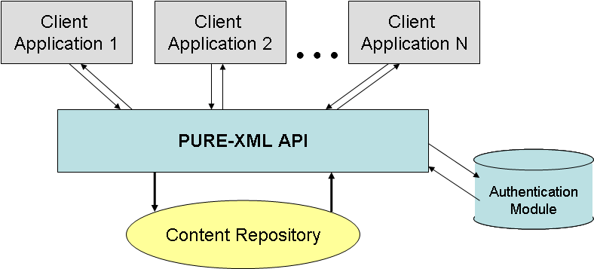

Client Applications
This specification is based on (but not restricted by) the requirements of the following applications that will use the repository:

Application | Description
AT4AM | Authoring Tool for Amendments. Specialised editor that enables creation, modification and management of amendments on legislative proposals. The tool has a local temporary repository. PURE-XML is used as storage only when the internal processing is completed.
AT4LEX | Authoring Tool for Legislative and Official documents, capable of assembling different sources of content (content assembly) into one legislative document.
DM-XML | XML Document management Web Services.
DST | Drafting Support Tool (Authoring tool for verification).
CAT4TRAD | Computer-Aided Tool for Translation. Specialised translation tool designed to handle multilingual source texts based on the Akoma Ntoso schema, covering translation, revision and validation.
ITER | ITER is a software tool for the follow-up of parliamentary activities, essentially covering the parliamentary committees' work and partially covering the plenary session.
EPADES-II | The "EPADES II" IT system provides a workflow definition, event recording, document exchange and repository system for documents processed within the European Parliament legislative circuit.

Constraints
PURE-XML must:
- provide central storage and search facilities for XML-oriented content.
- not be aware of the business workflow of its client applications (workflow-agnostic).
- fully support the IRO model.
- have a standards-based API

Object Model

PURE-XML must support the IRO information model. The IRO model is a hierarchical model providing support for both semantic and linguistic representation of documents. For a detailed and complete description of the IRO model please refer to [R1]. The logical level of the IRO model is presented on the diagram below:

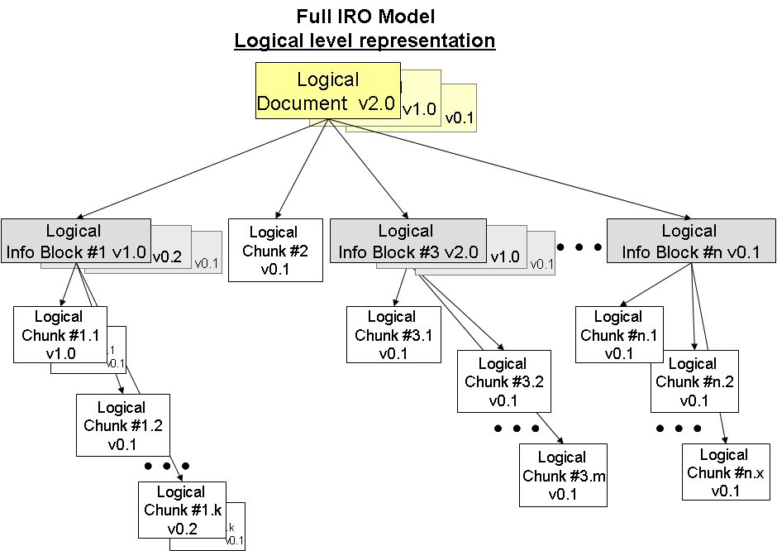

PURE-XML Model
The logical representation of the documents that will be stored in PURE-XML is presented in the diagram below:

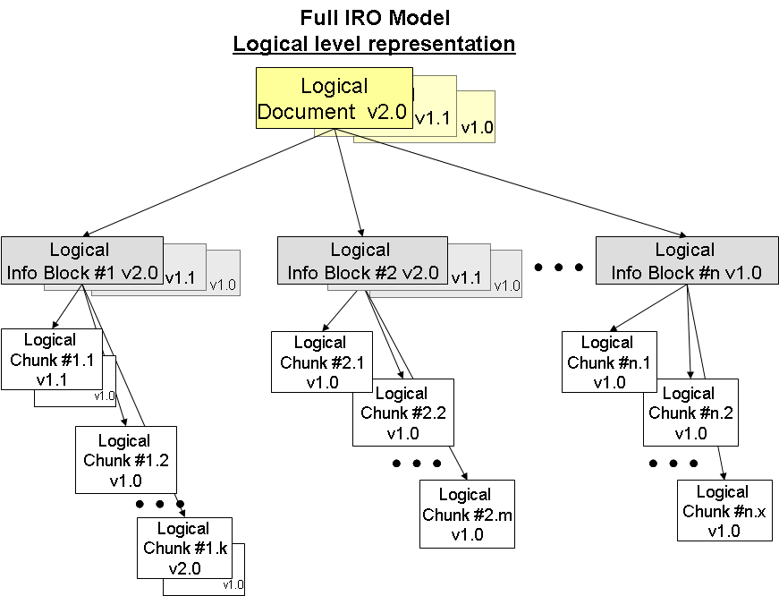

The IRO Generic Content Model must be fully supported.

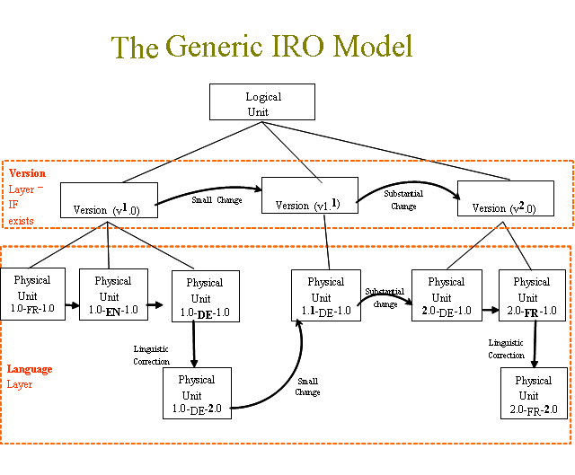
Client applications have to use the Logical and Physical Unit objects for the representation of the IRO model objects (Documents, Information Blocks and Chunks).

Containment Rules
The IRO model defines a hierarchical structure of Documents, Information Blocks and Chunks. PURE-XML must allow parent/child relationships and references between objects of the same level type (e.g. a Logical Document may contain a reference to another Logical Document).
All the versions of the Logical Units shall be considered as independent objects and may have different parents. All the versions of the Physical Units must belong under the same parent (Logical Unit).
Note: The IRO model defines the semantic meaning of the parent/child relationships of a Physical Unit (the Logical Unit contains the Physical Units).
The semantic meaning of the parent/child relationships of a Logical Unit is application-dependent and must be defined by the applications.

The Versioning Schema
The versioning schema is bi-directional:
- Horizontal (content versioning). All versions belong to the same Logical Unit.
- Vertical (language corrections). All versions belong to the same Physical Unit.

The complete versioning system must provide:
- Content versioning, including business-controlled major versioning and system-controlled minor versioning.
- Language identification.
- Language correction, including business-controlled major versioning and system-controlled minor versioning.

The structure for the full version identifier is:

version-id = content-version-id "-" lang-code '-' lang-correction-id
content-version-id = major "." minor
lang-correction-id = major "." minor
major = 1*DIGIT
minor = 1*DIGIT
lang-code = 2-letter code

Example: 1.5-en-1.0

The versioning system shall strictly apply the sequential order of the major and minor versions. The sequence for the version identifiers must start from "1.0".
Example: 1.0-en-1.0

"The Versioning Principles" section of [R1] provides a detailed description of the IRO versioning model.

N.B.: It is up to the client applications to decide if they will expose the versioning identifier or will present a user-friendly identifier via the "Version label" property.

Repository Objects
An overview is presented in the diagram below:
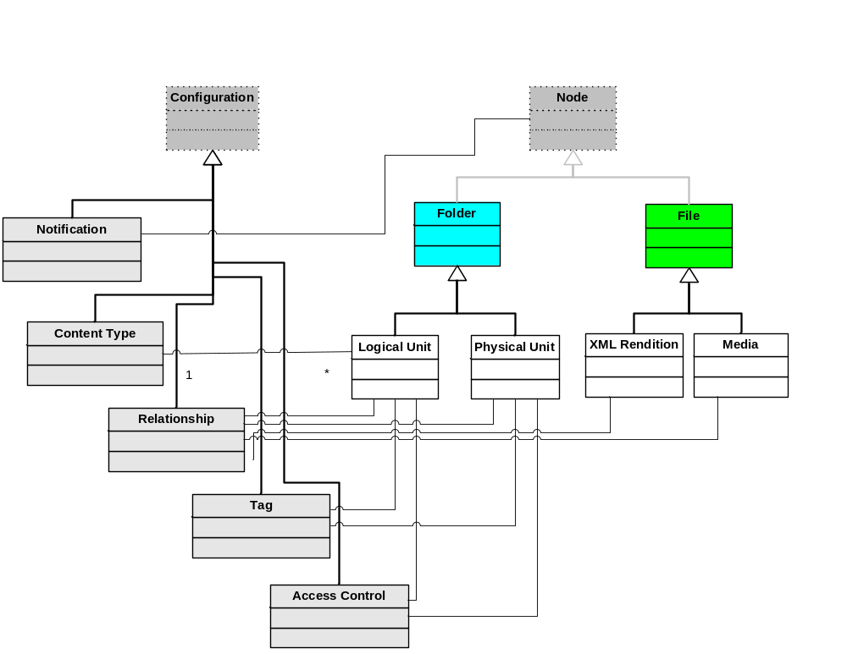
The following generic objects have to be supported:

A) Generic Objects

Object | Description | Constraints
Node | The Node is an abstract root object for the Folder and File objects of the repository. | All the Node-derived objects are fileable and have a URI.
Configuration | The Configuration object is an abstract system object for the definition of configuration parameters between the other repository objects (e.g. relationships, tags, Content-Types, etc) | The Configuration-derived objects are internal non fileable objects.
Folder | The Folder is a generic container for Folder and Folder-derived objects allowing for hierarchical representation of the repository contents. The Folder object must support user-defined ordering of its children and referenced objects. | The Folder object is a versionable object that can have as children other Folders or any other fileable object that is supported by the repository (including references to them).  The Folder object must have as parent another Folder object. Cycles are not allowed. A special "Root Folder" without parent must exist in the Repository. The hierarchical structure must be uniquely identified by URIs. The URI of the Root Folder is "/".  References (links) to other parents may exist.  It has only properties (no content).
File | Generic data container. | The File object is a non versionable leaf fileable object. The File object must have as parent a Folder object.  References (links) to other Folders may exist.  It has content and properties.

The repository may allow the creation of additional object types as extensions of the generic Folder and File objects.

The implementation must provide a simple, non-versionable, Folder object for the support of the hierarchical data structuring.

B) IRO Model Objects

The IRO Model supports multiple renditions (formats) per Physical Unit. PURE-XML will provide special support for the XML rendition and any binary media that accompany the XML text.

Logical Unit | The Logical Unit is a generic container for Logical Documents, Logical Information Blocks and Logical Chunks. | The Logical Unit object is a Folder-derived object with the following restrictions:  - It can have as children other Logical Units (respecting the IRO containment rules) or Physical Units.  - References (links) to other Folders and Logical Units may exist.  - Each Logical Unit is uniquely identified by its Unique Identifier (UID).
Physical Unit | The Physical Unit represents the collection of files that represent all the work done on one specific language for a specific semantic version of a Logical Unit. This includes all its linguistic corrections and renditions.  The IRO linguistic corrections are the version-nodes of this object. | The Physical Unit is a Folder-derived container with the following restrictions:  - Its parent can be only a Logical Unit.  - It has as name a language code.  - It can have as children only Renditions and Media.  - References (links) to other parents are not allowed.  - It has only properties (no content).
Rendition | The rendition represents the physical manifestation of a given linguistic version. | The Rendition is a File-derived non versionable object. It must have as parent always a Physical Unit.  References (links) to other parents are not allowed.  It has content and properties.
XML Rendition | The XML rendition | The XML Rendition is a Rendition with specific support for the XML content.
Media | The Media object is included for the support of binary content that is not included within the same file as the text. | The Media is a File-derived non versionable object. It must always have a Physical Unit as parent.  References (links) to other parents are allowed.  It has content and properties.

In the diagram below it is presented an example (not fully expanded) of the expected repository's structure.
Client applications are expected to define a hiearchical structure for the storage of each one of the different EP-document types that will have to be supported by PURE-XML.

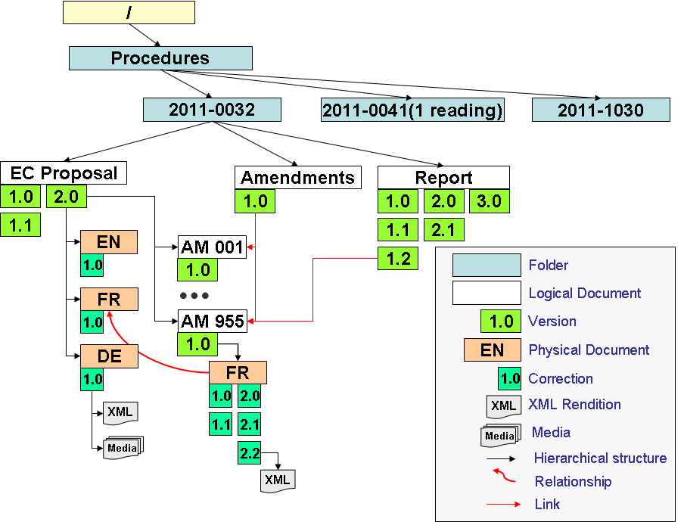

Repository Object Type Definitions

This section describes the different object types that must be supported by the PURE-XML content repository, as defined in paragraph 3.1.1.

Folder
Parent Object | "/" | <Folder>
Child Objects | <Folder> | <File> | <Logical Unit>
References | Allowed from Other Folder objects only
Tags | No
Relationships | Yes
Versionable | Yes
ACL support | Yes
Data content | No

System Properties
Name | Description | Status
Object ID | Unique object identifier. | Mandatory. System-defined.
Object type | The node’s object type (Folder, Logical Unit, Physical Unit, XML Rendition, Binary Rendition, Media) | Mandatory. System-maintained.
Parent | The parent object. It is set only at creation time. The references (links) do not change the parent. | Mandatory. System-maintained.
Name | Object name that has to be used for the URI representation of paths in the hierarchical structure of the repository. The name cannot contain URI reserved characters. Uniqueness constraints for the full URI path shall be applied.  In the URIs, the "Name" property alone identifies always the latest version. The pair "Name" and "Version ID" identifies uniquely a specific object of the version series. | Mandatory. User-defined.
Locked | Boolean flag. Locked entries cannot be modified (unless unlocked). The value of this property applies automatically to this object and all its children (recursive inheritance). | Mandatory. User defined. Default: False
Lock Owner | Username that locked the folder | Mandatory. System maintained.
Creator | Creator's username | Mandatory. System-maintained.
Creation Date | Creation timestamp | Mandatory. System-maintained.
State | Property for simple lifecycle support. | User-defined
Order ID | User-defined order of the object within the sequence of objects of the parent folder. If no value is provided at creation time, the last position of the sequence shall be taken. The user-provided value takes precedence and the parent folder order-list is automatically rearranged. | Optional. User- defined. Automatically updated by the system.
Order List | List with the ordering of the children and the referenced objects that are included in this folder. | System maintained.
Links | List of objects that have a reference of this one. The list is ordered based on the reference creation time. | System-maintained, only for objects that support references.
Tags | List of tags that have been assigned to this object. | System-maintained, only for objects that support tags.
Modification History | List of modifications (usernames, timestamps and operations) since the creation of the object. | See the Changelog module.
Related-to | List of relationships that this object is source | See the Relationships module.
Related-with | List of relationships that this object is target | See the Relationships module.
ACL | Access control list. The owner of the object always has full access rights on the object. | See the ACL module.
The properties below concern only the versionable objects
Version List | Versions list of this object (List of objects) | System maintained.
Version ID | Version identifier (major.minor) | System maintained.
Latest Version | Object of the latest version. | System maintained
Checkout | Contains the username if the node is checked-out. Empty otherwise. | System maintained.
Based On | Object that had been checked-out for the creation of this one. Empty for the first object of the series. | System maintained.
Version Label | Free-text version label | User-defined.
System properties lists will not be retrieved or updated through Get/Set system properties functions and will not be used for changelog and notifications. System properties Parent and Order ID will not be retrieved or updated through Get/Set system properties functions.

File
Parent Object | <Folder>
Child Objects | None
References | Allowed from Folder objects only
Tags | No
Relationships | Yes
Versionable | No
ACL support | Yes
Data content | Yes

System Properties
All the properties defined for the Folder object in 4.1.1. The properties below have to be supported as well:

Name | Description | Status
Size | File size (in bytes) | System-maintained
Media Type | IANA media-type | Mandatory. User-defined

Logical Unit
Parent Object | <Folder> | <Logical Unit>
Child Objects | <Logical Unit> | <Physical Unit>
References | Allowed from Other Folder and Logical Unit objects only
Tags | Yes
Relationships | Yes
Versionable | Yes
ACL support | Yes
Data content | No

System Properties
All the properties defined for the Folder object in 4.1.1. The properties below have to be supported as well:

Name | Description | Status
Unit Type | Logical Unit type (Document, Information Block, Chunk) | Mandatory. User-defined. Read only after node creation.
UBI | Unique Business Identifier. | Mandatory. User-defined.
Content-Type | Content-Type name (see section 6 for more details). | Mandatory. User-defined.
Subject | Semantics message summary | Optional. User-defined
Security Code | Security classification code | Optional. User-defined.

Physical Unit
Parent Object | <Logical Unit>
Child Objects | <Rendition>
References | No
Tags | Yes
Relationships | Yes
Versionable | Yes
ACL support | Yes
Data content | No

System Properties
All the properties defined for the Folder object in 4.1.1. The properties below have to be supported as well:

Name | Description | Status
UBI | Unique Business Identifier. |  | Mandatory. User-defined.
Language | Language code identifier | Mandatory. User-defined.
Original language | Language code identifier for the original language. | Mandatory. User-defined.
Content-Type | Content-Type name. It has the value of the same property in the parent Logical Unit. | Mandatory. System-maintained.
Note: The Physical Units must always belong to Logical Units that have the same "Content-Type" (constraint to be checked by the move function).

Rendition
This is a File-derived object for the renditions that the repository has to support. Client applications may use relationships in order to relate the Rendition with the Images of the Physical Unit.

Parent Object | <Physical Unit>
Child Objects | None
References | No
Tags | No
Relationships | Yes
Versionable | No
ACL support | No
Data content | Yes

System Properties
All the properties defined for the File object in 4.2.1.
The "Media Type" property is mandatory for all the renditions. The "Content-Type" property must be supported as well:
Name | Description | Status
UBI | Unique Business Identifier. | Mandatory. User-defined.
Content-Type | Content-Type name. It has the value of the property of the parent Physical Unit. | Mandatory. System-maintained.
Note: The renditions must always belong to Physical Units that have the same "Content-Type" The move function shall not be supported for Renditions.

XML Rendition
The XML Rendition is the Rendition with specific support for XML content. The following additional system property must be supported:
Name | Description | Status
XML schema | Reference to the XML schema used for this document. | Optional. User-defined.

Media
This is a File-derived object for the various media (images, etc) that are not supported by the Rendition format. Client applications may create references of the same Media between different versions of the Physical Unit in order to avoid copying the same content multiple times in the repository. Client applications may use relationships in order to relate the Media with the Renditions of the Physical Unit (in case not all Images belong to all Renditions).

Parent Object | <Physical Unit>
Child Objects | None
References | Yes
Tags | No
Relationships | Yes
Versionable | No
ACL support | No
Data content | Yes

System Properties
All the properties defined for the File object in 4.2.1. The following additional system property must be supported:
Name | Description | Status
UBI | Unique Business Identifier. | Mandatory. User-defined.

Object-level CRUD functions

This chapter contains the functional specification of the basic read/write operations that have to be supported by the PURE-XML repository on top of the objects defined in the previous chapter.

Folder

Create
Input | Parent Object or Parent Object URI or "/" (Root Folder)  List of user-defined properties (see 4.1.1).
Output | Object
Conditions | The new folder name must not exist already in the parent folder. The user has "create" permission in the parent folder. The parent folder is not locked. If the "Order ID" is not provided in the properties the new object takes the last place in the "Order List".
Function | Instantiation of new Folder object under the given path.
Exceptions | Parent is not a Folder Object.  Folder name unique constraint violation.  Insufficient permissions.  No space available.  Invalid properties.

Get System Properties
Input | N/A
Output | List of Object's system properties.
Conditions | The user has "read" permissions on the object.
Function | Return a list with the object's system properties.
Exceptions | Insufficient permissions.

Update System Properties
Input | List of user-defined system properties (see 4.1.1).
Output | Boolean flag
Conditions | The object exists and is not locked. The user has "update" permissions on the object.
Function | Update the system properties of the given object. Apply all the constraints for the object's properties. Client applications shall use the access control module in order to provide safe editing functionality.
Exceptions | Insufficient permissions.  No space available.  Invalid properties.  Not supported action for the root object.  Renaming of PWC is not allowed

Delete
Input | N/A
Output | Boolean flag
Conditions | The object is empty (no child objects exist) and is not locked. The user has "delete" permissions on the object. The object is the latest version of the versions sequence.
Function | Removal of the given object. All the references of this object are destroyed. If this is the only version then the whole Folder is removed.
Exceptions | Object is not empty.  Insufficient permissions.  Not supported action for the root object.  You cannot delete the PWC. Use "cancel checkout" instead.

Lock
Input | limited (Boolean flag, optional, default: false)
Output | Boolean flag
Conditions | The object is not locked. The user has "update" permissions on the object.
Function | Lock this object and all the inheriting children. If the limited parameter is true, lock only this object.
Exceptions | Insufficient permissions.

Unlock
Input | limited (Boolean flag, optional, default: false)
Output | Boolean flag
Conditions | The object is locked. The user is the lock owner and has "update" permissions on the object.
Function | Unlock this object and all the inheriting children. If the limited parameter is true, unlock only this object.  N.B.: Users with "admin" permissions can unlock objects unconditionally.
Exceptions | Insufficient permissions.

Link
Input | Target Folder Object or URI  Latest (Boolean flag, default: false; Type of link for versionable objects).  Order ID (Optional; Position of the object in the target folder)
Output | Boolean flag
Conditions | The Folder Object exists. The user has "create" permissions on the target. The target Folder is not locked.
Function | Create a reference of this object to the given Folder. Add the Folder to the "Links" property list of this object and to the "Order List" of the Folder. The unique constraint for the folder name must be applied. If the Order ID is not given, the linked object will take the last position on the target. If the Latest parameter is true then the link points always to the latest version of the object. If it is false the link remains with this Object.  N.B.: The link operation concerns only this object and not all the objects of the series of a versionable object.
Exceptions | Insufficient permissions.  Folder name already exists.  Not supported action for the root object.  Invalid object type.

Unlink
Input | Folder Object or URI
Output | Boolean flag
Conditions | The Folder Object exists. The user has "delete" permissions on the target. The Folder is not locked and it contains a reference (link) to this object.
Function | Remove the reference of this object to the given Folder. Remove the Folder from the "Links" property list. Update the "Order List" of the Folder.
Exceptions | Insufficient permissions.

Move
Input | Target Object or URI  Order ID (optional)
Output | Boolean flag
Conditions | The target Folder object exists. The user has "create" permissions on the target and on this object's parent. The source and target objects are not locked. The target does not contain a reference to this object.
Function | Move this object to the given target. The object's creation constraints must be applied. Update the "Order List" of both the source and the target folders. If the Order ID is not given, the moved object will become the last on the target.
Exceptions | Insufficient permissions.  Object name already exists.  Object creation constraint violation (URI, UBI, etc)  The object is PWC

Get Children
Input | Filter: optional, list of properties and values that the returned objects must have.  Latest-version: optional, default: false.
Output | List of Objects.
Conditions | The object exists. The user has "read" permissions on the object.
Function | Return an ordered list with the Objects of the object's children (including links). If the filter parameters are defined, return only those items that satisfy the given filter. For versionable objects, all the objects of the series are returned unless the latest-version parameter is set. For linked versionable objects the returned object depends on the link type at creation time (see 5.1.7).
Exceptions | Insufficient permissions.

File

Create
Input | Parent Folder Object or URI  List of user-defined properties (see 4.2.1), content-data
Output | Object
Conditions | The Parent Object is a Folder Unit. The user has "create" permission in the parent object. The parent object is not locked. If the "Order ID" is not provided in the properties then the new object takes the last place in the "Order List".
Function | Instantiation of a new File object under the given Folder.
Exceptions | Parent is not a Folder object.  Insufficient permissions (on the parent).  No space available.  File size exceeded configurable upper limit.  Invalid properties / content-data.

Get System Properties
Identical to 5.1.2

Get Content
Input | N/A
Output | content-data
Conditions | The user has "read" permissions on the object.
Function | Return the content-data of the object.
Exceptions | Insufficient permissions.

Update System Properties
Identical to 5.1.3

Update Content
Input | List of user-defined properties (see 4.5.1), content-data
Output | Boolean flag
Conditions | The user has "update" permissions on the object. The object is not locked. If the parent is a versionable object, then the parent must be the PWC copy of the checked-out version.
Function | Update the properties and the content-data of the given object. Apply all the constraints for the object's properties and content-data.
Exceptions | Insufficient permissions.  No space available.  File size exceeded configurable upper limit.  Invalid properties / content-data

Delete
Input | N/A
Output | Boolean flag
Conditions | The user has "delete" permission in the parent. The parent is not locked. The object is not locked.
Function | File removal. The File is removed and the parent's "Order List" has to be updated.
Exceptions | Insufficient permissions.

Lock
Identical to 5.1.5

Unlock
Identical to 5.1.6

Link
Input | Target Folder Object or URI  Order ID (Optional; Position of the object in the target folder)
Output | Boolean flag
Conditions | The Folder Object exists. The user has "create" permissions on the target. The target Folder is not locked.
Function | Create a reference of this object to the given Folder. Add the Folder to the "Links" property list of this object and to the "Order List" of the Folder. The unique constraint for the name must be applied. If the Order ID is not given, the linked object will take the last position on the target.
Exceptions | Insufficient permissions.  File already exists.

Unlink
Input | Folder Object or URI
Output | N/A
Conditions | The Folder Object exists. The user has "delete" permissions on the target. The Folder is not locked and it contains a reference (link) to this object.
Function | Remove the reference of this object to the given Folder. Remove the Folder from the "Links" property list. Update the "Order List" of the Folder.
Exceptions | Insufficient permissions.

Move
Input | Target Object or URI  Order ID (optional)
Output | Boolean flag
Conditions | The target Folder object exists. The user has "create" permissions on the target and on this object's parent. The source and target objects are not locked. The target does not contain a reference to this object.
Function | Move this File to the given target. The object's creation constraints must be applied. Update the "Order List" of both the source and the target folders. If the Order ID is not given, the moved object will take be the last on the target.
Exceptions | Insufficient permissions.  File already exists.  Object creation constraints violation.  The rendition nodes cannot be moved.

Logical Unit
All the functions of the Folder object have to exist for this object as well. The "create", "link" and "move" functions are redefined. A new function named "Get Content Properties" is added.

Create
Input | Parent Object or Parent Object URI or "/" (Root Folder)  List of user-defined properties (see 4.3.1).
Output | Object
Conditions | The new Logical Unit name must not exist already in the parent folder. The user has "create" permission in the parent folder. The parent folder is not locked. The IRO containment rules are respected (e.g. if the given type is Logical Information Block then the parent cannot be a Logical Chunk).
Function | Creation of a new Logical Unit object under the given path.
Exceptions | Parent is not a Folder Object.  Logical Unit name unique constraint violation.  Logical Unit hierarchy constraint violation.  Insufficient permissions.  No space available.  Invalid properties.

Link
Input | Target Object or URI  Latest (Boolean flag, default: false; Type of link for versionable objects).  Order ID (Optional; Position of the object in the target folder)
Output | Boolean flag
Conditions | The Folder Object exists. The user has "create" permissions on the target. The target Folder is not locked.
Function | Create a reference of this object to the given target. Add the Logical Unit to the "Links" property list of this object and to the "Order List" of the target. The unique constraint for the folder name must be applied (as in the case of the creation of a new child). If the Order ID is not given, the linked object will take the last position on the target.  The IRO containment rules must be respected. Links between Logical Units of the same level are allowed.  If the Latest parameter is true then the link points always to the latest version of the object. If it is false the link remains with this Object. For versionable objects, only one object of the series can have a link under that parent, if that parent is a Logical Unit object.  N.B.: The link operation concerns only this object and not all the objects of the series of a versionable object.
Exceptions | Insufficient permissions.  Object name already exists on the target.  IRO containment rules violation.  The target and parent objects are the same

Move
Input | Target Object or URI  Order ID (optional)
Output | Boolean flag
Conditions | The target Folder object exists and it has the same or higher level in the IRO hierarchy. The IRO containment rules must be respected. The user has "create" permissions on the target and on this object's parent. The source and target objects are not locked. The target does not contain a reference to this object.
Function | Move this Logical Unit to the given target. The object's creation constraints must be applied. Update the "Order List" of both the source and the target folders. If the Order ID is not given, the moved object will take be the last on the target.
Exceptions | Insufficient permissions.  Object name already exists on the target.  Object creation constraint violation (URI, UBI, etc)  IRO containment rules violation.

Physical Unit
The Physical Unit object must support only the functions defined below.

Create
Input | Parent Object or URI  List of user-defined properties (see 4.4.1).
Output | Object
Conditions | The Parent Object is a Logical Unit. The given language does not exist in that Logical Unit. The user has "create" permission in the parent object. The parent object is not locked.
Function | Creation of a new Physical Unit for that Logical Unit. The "Name" property must be identical to the "Language" property.
Exceptions | Parent is not a Logical Unit object.  A Physical Unit for the same language already exists.  Insufficient permissions.  No space available.  Invalid properties.

Get System Properties
Identical to 5.1.2

Update System Properties
Identical to 5.1.3

Delete
Input | N/A
Output | N/A
Conditions | The object is not locked or checked-out. The user has "delete" permission. The object is the latest version of its versions sequence.
Function | Physical Unit removal including all its renditions. If this is the only version then the whole object is removed and the parent's "Order List" has to be updated.
Exceptions | The Physical Unit is not empty.  Insufficient permissions.  You cannot delete the PWC. Use "cancel checkout" instead

Lock
Identical to 5.1.5

Unlock
Identical to 5.1.6

Get Children
Identical to 5.1.10

Rendition
All the applicable functions of the File object have to exist for this object as well, respecting the restrictions defined in paragraph . The create function is redefined.

Create
Input | Parent Physical Unit Object or URI  List of user-defined properties (see 4.5.1), content-data
Output | Object
Conditions | The Parent Object is a Physical Unit. The user has "create" permission in the parent object. The parent object is not locked.
Function | Creation of a new Rendition for the Physical Unit. Application of the content-type specific constraints (e.g. for the XML rendition, the content-data may have to be validated with the given schema).
Exceptions | Parent is not a Physical Unit object.  Insufficient permissions (on the parent).  No space available.  File size exceeded configurable upper limit.  Invalid properties / content-data.  Invalid object type  Rendition name unique constraint violation

Update XML Content (for XML Renditions only)
Input | Xpath expression  value
Output | Boolean flag
Conditions | The user has "update" permission. The object is not locked. The parent Physical Unit must be the PWC copy (see versioning section for more details) of the checked-out version.
Function | Modify the XML content according to the given input (Change the value of the given Xpath).
Exceptions | Insufficient permissions.  Invalid Object (Parent is not a PWC object).  No space available.  Invalid Xpath expression / content-data  File size exceeded configurable upper limit.

Media
All the applicable functions of the File object have to exist for this object as well, respecting the restrictions defined in paragraph 3.1.1.

Content-Types

The PURE-XML repository must provide support for the definition of Content-Types and their properties. The Content-Type will be assigned at the level of the Logical Units. The Physical Units and the Renditions inherit automatically the Content-Type of their parent.

The Content-Types allow the client applications to define custom properties related to their content or their business workflow. Content-Type properties are managed independently of the XML content and they can be updated and modified without the need of the check-out/in change and versioning operations.
The definition of Content-Type properties is linked to a Content-type and is done at the system level via the PURE-XML management console.

Related to a Content-Type is the concept of XML metadata which identifies, via an xpath expression, the metadata that will be indexed by the system and included in the Search service.
As per the Content-Type and Content-Type properties also the XML metadata will be defined using the PURE-XML management console. PURE-XML will provide read-only access to the XML metadata. Modifications to the XML metadata can occur only with the content-related functions (versioning is required). All the XML metadata will be considered of type "String" as they belong to the XML content.

Content-Type Object
The Content-Type Object is a Configuration derived object that defines a Content-Type. It has the properties listed below:

Name | Description | Status
Object ID | Unique object identifier. | Mandatory. System-defined.
Name | Content-Type name. Unique constraint applies. The name cannot contain URI reserved characters. | Mandatory. User-defined.
Description | Content-Type description. | Optional. User-defined.
Creator | Creator's username | System maintained.
Creation time | Creation timestamp | System maintained.
Logical-level properties | List of logical-level (language-independent) content property definitions. | Optional. User defined.
Physical-level properties | List of physical-level (language-dependent) content property definitions. | Optional. User defined.
Rendition-level properties | List of rendition-level (format) content property. | Optional. User defined.
Rendition-level XML metadata | List of XML metadata definitions that shall be used as search criteria for XML Renditions | Optional. User defined.

Define Content-Type
Input | Content-Type Object properties (see paragraph above)
Output | Content-Type Object
Conditions | The user has "admin" permissions for the repository.
Function | Creation of a new Content-Type or update of an existing one.  When the parameter is a new Content-Type, the function will define the new Content-Type.  When it is an existing Content-Type, the system will update its definition. The update will be non-destructive. Only new Content-Type properties and new metadata entries can be defined. Deletions will not be possible (error will be returned).
Exceptions | Removal of existing properties or metadata is not allowed.  Insufficient permissions.

Undefine Content-Type
Input | Content-Type Object
Output | Boolean flag
Conditions | The user has "admin" permissions for the repository. The Content-Type is not assigned.
Function | Removal of the Content-Type.
Exceptions | Insufficient permissions.  Content-Type already in use.

Get Content-Type by Name
Input | Content-Type Name
Output | Content-Type Object
Conditions | None
Function | Get the Content-Type Object that has the given name
Exceptions | No Content-Type found

Get All Content-Types
Input | N/A
Output | List of Content-Type Objects
Conditions | None
Function | Get a list with all the Content-Type Objects in the repository.
Exceptions | No Content-Type found

Delete Content-Type XML metadata
Input | Content-type name, XML metadata property name
Output | None
Conditions | The user has "admin" permissions for the repository. The given Content-Type name and XML metadata property name already exist.
Function | Delete the XML metadata
Exceptions | Insufficient permissions  No Content-Type found  No XML metadata found

Object Functions
The objects that support Content-Types must also provide the following function:

Get Content-Type Properties
Input | N/A
Output | List of content-type properties (and their values)
Conditions | The user has "read" permissions on the object.
Function | Return a list with the object's content-type properties (and their values) that corresponds to the complete list of properties defined by the Content-Type of the object. Logical Units must use the "Logical-level properties" of the Content-Type. Physical Units must use the "Physical-level properties" of the Content-Type. Renditions must use the "Rendition-level properties of the Content-Type.  The returned list must always have the same ordering.
Exceptions | Insufficient permissions.

Set Content-Type Properties
Input | List of content-type properties (and their values)
Output | boolean flag
Conditions | The user has "update" permissions on the object. The provided properties correspond to the IRO level of the object.
Function | Set the object's Content-Type properties.
Exceptions | Insufficient permissions.

Get XML Metadata
Input | N/A
Output | List of XML metadata (and their values)
Conditions | The user has "read" permissions on the object.
Function | Return a list with the XML metadata (and their values) that corresponds to the complete list of XML metadata that have been defined by the Content-Type of the object. N.B.: This method must be available only for XML Renditions.  The returned list must always have the same ordering.
Exceptions | Insufficient permissions.

Search support
The search service (see chapter 10) shall provide the same support for the Content-Type properties as for the other system properties.

The XML metadata shall be possible to be searched as well (full-text search support), restricting the search scope with their XPath.

Relationships

The PURE-XML repository must support the creation of user-defined relationships and apply those relationships between the repository's objects. The semantics of the relationships are user-defined. The users must have "relation" permissions in order to create and delete relationships. Relationships can be created between any object (including the versions of the versionable objects). The modification of the relationships of an object shall not be considered as a modification of the object itself. The relationships link only the source and target objects and there is no inheritance. The system shall maintain the internal "Related-to" and "Related-with" properties for each object that supports relationships.

Relationship Object
The Relationship Object is a Configuration derived object that defines a relationship. It has the properties listed below:
Name | Description | Status
Object ID | Unique object identifier. | Mandatory. System-defined.
Name | Relationship name. Unique constraint applies. The name cannot contain URI reserved characters. | Mandatory. User-defined.
Description | Description of the relationship. | Optional. User-defined.
Creator | Creator's username | System maintained.
Creation time | Creation timestamp | System maintained.
Source | List of allowed source object types. | Mandatory. User-defined.
Target | List of allowed target object types. | Mandatory. User-defined.

Define Relationship
Input | Relationship Object properties (see paragraph above)
Output | Relationship Object
Conditions | The user has "admin" permissions for the repository.
Function | Create or update a relationship.
Exceptions | Insufficient permissions.  The relationship's object type is already used.

Undefine Relationship
Input | Relationship Object
Output | Boolean flag
Conditions | The user has "admin" permissions for the repository. The relationship is not used.
Function | Removal of a relationship.
Exceptions | Insufficient permissions.  Relationship already in use.

Get Relationship by Name
Input | Relationship Name
Output | Relationship Object
Conditions | None
Function | Get the Relationship Object that has the given name.
Exceptions | No relationship found.

Get All Relationships
Input | N/A
Output | List of Relationship Objects
Conditions | None
Function | Get a list with all the Relationship Objects in the repository.
Exceptions

Object Functions
Each object supporting Relationships must support the following functions:

Create Relationship
Input | Relationship Object  Source Object  Target Object
Output | Boolean flag
Conditions | This object is an allowed source object for the given relationship. The user must have relation permissions for the source and the target object.
Function | Create a relationship with the target. Add the relationship and the target in the "Related-to" property. Add the relationship and this object in the "Related-with" property of the target. The creator and the creation date have to be saved as well.
Exceptions | Invalid relationship (object is not allowed as source).  Not allowed target object type.  Relationship already exists.  Insufficient permissions.  Not supported action for the root object.  The target and source is the same node.

Delete Relationship
Input | Relationship Object  Source Object  Target Object
Output | Boolean flag
Conditions | The relationship exists.
Function | Remove the relationship with the target. Update the "Related-to" property of this object and the "Related-with" property of the target.
Exceptions | Invalid relationship (object is not the source).  Not allowed target object type.  Insufficient permissions.

Get Related Objects
Input | Relationship Object
Output | List of target Objects
Conditions | The relationship exists. The user must have read permissions.
Function | Get a list of all the target objects for the given relationship.
Exceptions | Insufficient permissions.

Get Source Relationships
Input | N/A
Output | List of Relationship Objects
Conditions | The user must have read permissions.
Function | Get a list of all the relationships that have been created with this object as source.
Exceptions | Insufficient permissions.

Get Target Relationships
Input | N/A
Output | List of Relationship Objects
Conditions | The user must have read permissions.
Function | Get a list of all the relationships that have been created with this object as target.
Exceptions | Insufficient permissions.

Search for Relationships
The search interface (see chapter 10) shall allow the usage of the "Related-to" and "Related-with" properties in the search criteria.

The "equal" operator must be supported.

The searched value must be the Relationship Name.

Tagging

The PURE-XML repository must support the creation and assignment of user-defined tags to the repository's objects. The semantics of the tags are user-defined. The users must have "update" permissions in order to add or remove tags from the objects. The creation of the tags requires "admin" privileges.

Multiple tags can be assigned to any single object. Each tag can be assigned only once to any given object. A tag that has been created with the unique constraint enabled can appear only for one object of the version series, if the object is versionable.

Add and delete operations of tags shall be logged.

Tag Object
The Tag Object is a Configuration derived object that defines a tag. It has the properties listed below:
Name | Description | Status
Object ID | Unique object identifier. | Mandatory. System-defined.
Name | Tag name. Unique constraint applies. The name cannot contain URI reserved characters. | Mandatory. User-defined.
Description | Description of the tag. | Optional. User-defined.
Unique constraint | Boolean flag | Default: false

Define Tag
Input | Tag Object properties (see paragraph above)
Output | Tag Object
Conditions | The user has "admin" permissions for the repository.
Function | Creation of a new tag.
Exceptions | Insufficient permissions.

Undefine Tag
Input | Tag Object
Output | Boolean flag
Conditions | The user has "admin" permissions for the repository. The Tag is not used.
Function | Removal of the given tag.
Exceptions | Insufficient permissions.  Tag already in use.

Get Tag by Name
Input | Tag Name
Output | Tag Object
Conditions | None
Function | Get the Tag Object that has the given name
Exceptions | No tag found.

Get All Tags
Input | N/A
Output | List of Tag Objects
Conditions | None
Function | Get a list with all the Tag Objects in the repository.
Exceptions

Object Functions
Each object supporting Tags must support the following functions:

Add Tag
Input | Tag Object or Tag name
Output | Boolean flag
Conditions | The user must have update permissions for this object.
Function | Add the given tag to this object. If the unique constraint of the tag is true, and if the object is versionable, this tag will be automatically removed from any other object of the version series.
Exceptions | Tag already exists.  Insufficient permissions.  Invalid object type (This object does not support tags)

Delete Tag
Input | Tag Object or Tag name
Output | Boolean flag
Conditions | The user must have update permissions for this object.
Function | Remove the given tag from this object.
Exceptions | Invalid relationship (object is not the source).  Not allowed target object type.  Relationship already exists.  Insufficient permissions.

Search for Tags
The search interface (see chapter 10) shall allow the usage of the "Tags" properties in the search criteria.

The "equal" operator must be supported.

The searched value must be the Tag Name.

Versioning

The PURE-XML repository must fully support the IRO versioning model (see 3.1). The major and minor numbering sequences must be maintained automatically by the system. The type of the change (major / minor) is user-defined.
The system must automatically maintain the "Based On" property. Any object from the version series can be checked-out.

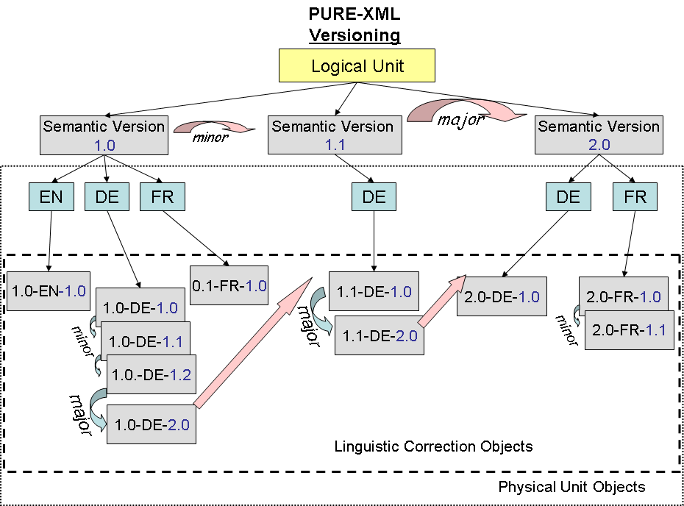

All versions shall be considered as independent objects and must be visible for the search operations. The sequential ordering of the major and minor version sequences are automatically maintained by the system.
The system shall automatically update the "Based On" property with the checked-out object that has been used for the creation of the new version (support for branch sequences within the version series).

The next diagram illustrates the "Based on" relationships. Client applications may use the "Version label" property for alternative versioning schemas, in case the system version numbers are not convenient. The numbers in circles define the order of execution of the checkin operations.

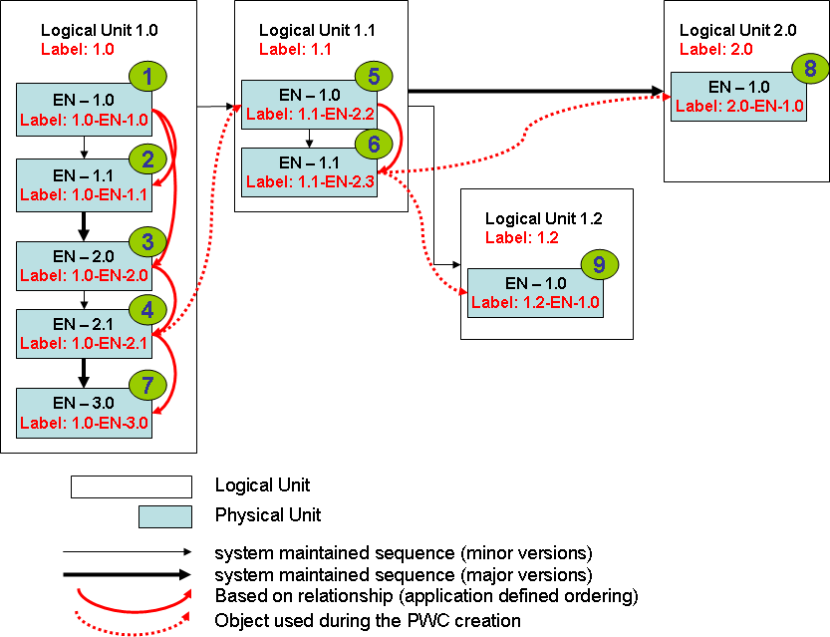

Object functions
All versionable objects must support the functions below:

Get Versions
Input | N/A
Output | List of Objects
Conditions | The object is versionable. The user has "read" permissions on the object.
Function | Return an ordered (version-id descending) list of the Objects that correspond to the version nodes of this object.
Exceptions | Insufficient permissions.

Get Latest
Input | N/A
Output | Object.
Conditions | The object is versionable. The user has "read" permissions on the object.
Function | Get the latest version object.
Exceptions | Insufficient permissions.

CheckOut
Input | copy-children (boolean flag, default: false)  children-list (optional list of top-level children that will be copied in the new version)
Output | Object of the private working copy (PWC).
Conditions | The user has "version" permissions. The object is not empty, it is not already checked-out and the parent is not locked.
Function | Versionable Object check-out. The object is marked as checked-out by that user. No further modifications can occur in its contents. A private working copy (PWC) of that Object is created and it becomes available (visible) only for that user. If the copy-children parameter is true, the system shall copy under the PWC the latest version of the versionable children (recursively). The version-id of the versionable children of the PWC shall be reset to "0.1" (recursively). The children-list parameter can limit the children that will be copied into the PWC.
Exceptions | Insufficient permissions.  Object already checked-out.  No space available.  The object is not versionable.  The children list is invalid.  The object is PWC.  Not supported action for the root object.

CheckIn
Input | change-type ([minor|major], default: minor)
Output | Object
Conditions | This object is a checked-out document. The parent is not locked. The user has "version" permission.
Function | Versionable Object check-in. The PWC of the object becomes the latest version. The version-id is set to the next value of the sequence (depending on the change-type parameter). Minor changes must take the next value of the minor counter sequence under the major version of the checked-out object. Major changes must take the next value of the major counter sequence and reset the minor counter to zero. The latest-id property of the series is updated. The "Checkout" property of the node is cleared. The "Based-on" property of the new version is set to this object. The parent of this object remains parent for the new version as well.  If the content has not been changed, it is up to the client application to call a Cancel CheckOut operation. Every CheckIn operation increases the version number regardless of the content being changed.
Exceptions | Object is not checked-out.  Insufficient permissions.  The object is not versionable.  The UBI already exists.  Tag unique constraint violation.

Cancel CheckOut
Input | N/A
Output | N/A
Conditions | This object is checked-out. The user has "version" permission and is the owner of the checkout lock.
Function | Cancellation of the check-out process. The private working copy is deleted. The latest-version of the parent remains unchanged.
Exceptions | Insufficient permissions.  The object is not versionable.  The Object is not checked-out.  The PWC content data has been changed.

URI mapping
As defined in paragraph 4.1.1, the URI of all the objects is defined using the "Name" property and the version identifier for versionable objects. For non-versionable objects the URI contains only the "Name" property of the object.
Versionable objects can be represented in URIs following the notation below:

Name ":" Major VersionID "." MinorVersionID

Examples:

URI | Description
/Folder:1.0/LogicalUnit1:1.0/en:1.0/logo | The file logo of the 1.0 version of the "en" translation of the 1.0 version of logical unit with name "LogicalUnit1"
/Folder1:1.0/LogicalUnit1:1.2 | Version 1.2 of the the logical unit with name "LogicalUnit1" under the folder with name "Folder1" and version 1.0.
/Folder:1.0/LogicalUnit1:1.2/en:1.1 | The 1.1 version of the EN translation of version 1.2 of the logical unit with name "LogicalUnit1"
/Folder:1.0/LogicalUnit1:1.2/en:1.0 | EN linguistic correction 1.0 of version 1.2 of the logical unit with name "LogicalUnit1".
/Folder/LogicalUnit1:0.2/en:1.0?PWC | The private working copy of the checked-out EN linguistic correction 1.0 of the logical unit with name "LogicalUnit1".

Search

The PURE-XML repository must provide search capabilities for all the object properties and their relationships. Full-text search must be enabled for the objects that have content-data (Renditions). Mixed search criteria (full-text and properties) must also be allowed. The search shall operate recursively on the objects. The results set must be a list of Objects. Support for ordering of the results must be included.

Search criteria
The search criteria consist of a list of search entries (properties, comparison operators and values). The search entries can be connected with the Boolean operators AND, OR and NOT.

Properties
System and content-type properties can be searched with the operators defined below:

Boolean
The user shall be able to search in all numerical value properties using the operators below:
- is true

Numerical, Date
The user shall be able to search in all numerical and date value properties using the operators below:
- equal
- greater than
- less than

URI
The user shall be able to search in all URI properties using the operators below:
- is
- matches (pattern matching syntax)

String
The user shall be able to search in all string properties using the operators below:
- is
- matches (pattern matching syntax)

Full Text
The user shall be able to search in the text of the content-data (full words only) using the operators below:
- is
- contains
It shall be possible to restrict the scope of the full-text search with the Text Path expressions that are defined in the content type’s XML metadata.

Relevance information must be collected (number of occurrences of the searched value in the content-data).

Ordering
The search interface must support the ordering of the results in the returned result set. The user shall be able to define ascending or descending ordering (numeric or alphabetic sorting for numerical and text values respectively) and a list of properties that shall be used for the ordering.
In case the full-text search operator is included in the search criteria, it must be possible to order by "Relevance".

Search functions
The Folder objects shall support the search function as defined below. The search operation will be relative to the URI of the object.

Search
Input | Search criteria  Order by (default: none)  max-results (default: configurable)
Output | List of Objects
Conditions | The user has read permissions on this Folder.
Function | The system shall return all requested Objects that satisfy the provided search criteria and for which the user has at least read access. An empty list shall be returned if no objects have been found. The search criteria may concern properties and / or content-data of this Folder's descending objects.  The returned list must be ordered according to the given "Order by" parameter. The list must contain only the objects for which the user has read permissions.  The max-results parameter defines the maximum number of objects that the search operation will return.
Exceptions | Insufficient permissions.

Access Control

The PURE-XML repository must provide access control management functions for all the repository objects that require ACL support. The permissions must apply to the current object and all inheriting objects, recursively. The permissions set on the object itself must take precedence over the permissions inherited from the parent object.

Authentication
Access to the PURE-XML API must be granted only to authorised users. The authentication itself is not a service offered by the system itself. The authentication process must return for each user a list of groups/roles that the authenticated user belongs too. The access control module must control the user access based only on group membership information. The group identifiers that can be used in the access control entries have to be defined in the system's management console.

Permission Levels
The system shall support a hierarchical model of permissions (each next level includes all the previous access rights as well).

Level | Name | Allowed functions
0 | none | No access.
1 | read | Permission to read the object's properties and content.
2 | relation | Permission to create relationships on this object.
3 | version | Permission to create new versions.
4 | create | Permission to instantiate new children in the object.
5 | update | Permission to update the object's properties and content.
6 | delete | Permission to remove an object.
7 | admin | No restrictions.
Additional rights that can be combined with any of the previous levels
 | ACL | ACL get/set operations.

Note: The admin level includes the ACL level as well.
Annex II presents a summary of all the object functions and the required permissions.

Group definition
All the groups that can be used in the ACL entries have to be defined. The Active directory group name shall correspond to the name of the groups/roles provided by the authentication module (login).

Define Group
Input | Group name
Output | Group Object
Conditions | The user has "admin" permissions for the repository.
Function | Creation of a new group identifier.
Exceptions | Insufficient permissions.  Group name alias already exists.  Active directory group name already exists.

Undefine Group
Input | Group Object
Output | Boolean flag
Conditions | The user has "admin" permissions for the repository. The Group is not used in the ACLs.
Function | Removal of the group.
Exceptions | Insufficient permissions.  Group already in use.

Get Group by Name
Input | Group Name
Output | Group Object
Conditions | None
Function | Get the Group Object that has the given name
Exceptions | No group found

Get All Groups
Input | N/A
Output | List of Group Objects
Conditions | None
Function | Get a list with all the Group Objects that can be used in the ACLs of the repository.
Exceptions

Access Control Lists
The system shall maintain an internal "ACL" property for all the objects of the repository that must have ACL support. The ACL property is a list of access control entries (ACEs).
The ACE shall contain the allowed permission level, a list of user groups/roles that have this permission and a flag indicating if this permission is directly assigned to the object.

The access control management is done internally and the client applications have to use only the functions defined in this paragraph.

Each object supporting Access Control Management must support the following functions:

Get ACL
Input | N/A
Output | List of ACEs.
Conditions | The user must have ACL-modification permission.
Function | Get the access control list of this object.
Exceptions | Insufficient permissions.

Set ACL
Input | ACE or list of ACEs  Overwrite (optional, Boolean flag, default: False).
Output | N/A
Conditions | The user must have ACL-modification permission.
Function | Set the access control list of this object. If the overwrite parameter is "True", the ACL is overwritten. Otherwise, the current ACL is merged with the existing entries. The new entries take precedence over any conflicting existing entries.
Exceptions | Insufficient permissions.  Invalid ACE.

Notifications & Changelog

PURE-XML must provide a notifications and changelog mechanism that will allow client-applications to receive notifications and browse the modifications history of the repository's objects. The history must not be related with the objects (the history of deleted objects must remain accessible even after their removal).

Event Object
The Event Object is a Configuration derived object that defines a modification in the repository. The events are generated automatically by the system and must have the properties listed below:
Name | Description
Timestamp
Username
User groups/roles | A comma sepated list of groups/roles.
Action | See table below.
System's Object ID | The Object ID system property
Object URI  Object UBI (when available) | This object's URI  This object's UBI (only for the objects that support the UBI property)
Related Object URI  Related Object UBI (when available)  System’s related Object ID | The related object's identifiers. The related object depends on the logged operation and is available only when it makes sense (e.g. for the "node moved" action is the previous parent, for the "node linked" action is the new parent folder, etc)
Comment | Additional information, related to the logged event.

The following actions must be logged for each object:
Action | Description
node created | Initial object creation.
version created | Creation of new versions for versionable objects
node deleted | Object removal.
node moved | Object relocation.
node linked | Object link creation.
node unlinked | Object unlink operation.
property added | Setting of object's properties (first entry).
property changed | Modification of object's properties.
property deleted | Removal of object's properties.
ACL added | Setting of access control entries.
ACL changed | Modification of access control entries.
ACL deleted | Removal of access control entries.
relation created | New relationship.
relation deleted | Removal of a relationship. The related Object is the target object.
tag added | Tag addition.
tag deleted | Tag removal.

Notifications
PURE-XML must provide an asynchronous notification mechanism, which will allow the client applications to receive and react upon repository modifications. It shall be possible to limit the notifications only under a given repository URI or action and allow multiple applications handling the same notifications in parallel.

The handling of the notifications shall be under the sole responsibility of the client applications. The communication mechanism will be defined by the implementation.

Client applications shall be possible to register for notifications based on different topics. Example of topics can be all objects that:
• are under a given folder
• have the same content-type
• share a tag or relationship
• have the same owner

Client applications could also register for notifications based on particular object changes that can trigger an entry in the object's modification history (locked / unlocked objects, check-out/check-in of new versions, lifecycle state changes, etc).

Multiple client applications may register for the same notifications. It shall be possible to configure the system in order to expire automatically the notifications after a configurable amount of time. The notifications message structure shall be in XML and shall include all the necessary information for client applications in order to process and react on those events.

Modifications history
Each fileable object must support the following function:

Get Modifications History
Input | N/A
Output | List of Events
Conditions | The user must have "admin" permissions.
Function | Return the object's modification history.
Exceptions | Insufficient permissions.

Changelog support functions
In the frame of the changelog module, PURE-XML must support the following functions:

Changelog search
Input | URI | UBI | action | user | time frame | ID
Output | List of Events
Conditions | The user must have "admin" permissions.
Function | Return the changelog entries that satisfy the given criteria (search by URI prefix, by UBI, by action, by username, within a given time frame or by ID). The search by URI prefix shall operate as filter (i.e. display all the related entries under the given URI prefix and not only the single object that corresponds to the given URI).
Exceptions | Insufficient permissions.  Invalid date.

Changelog cleanup
Input | timestamp
Output | Boolean flag
Conditions | The user must have admin permissions.
Function | Removal all the changelog entries for the deleted objects before the given timestamp.
Exceptions | Insufficient permissions.  Parallel execution is not allowed.  Invalid date.

Miscellaneous support functions

This section contains the definition of miscellaneous support functions for client applications that do not fit in any of the previous sections.

Get Object
Input | URI or UBI
Output | Object
Conditions | The given URI or UBI corresponds to an existing object in the repository. See also definition for the versionable objects in paragraph 9.2
Function | Return the Object of the given URI or UBI.
Exceptions | The URI | UBI does not correspond to a repository object.

Statistics
PURE-XML must collect statistical data concerning the usage of the repository. Data that have to be collected are:

- Total number of items per object type (Folders, Logical Units, etc).
- Total number of items per Content-Type.
- Total number of API function calls, calls per user group, calls per Content-Type, per day, etc.
- Total and average number of versions for versionable objects.
- ...

PURE-XML API

PURE-XML API must have a Java and a Webservices binding. All the basic object functions have to be supported.

Java binding
Package name: ec.ep.purexml

Important: All the functions are atomic operations and they modify the repository upon their termination. The API must serialize the execution of concurrent calls (e.g. if two applications try to add the same child under a folder, then only one of them will succeed).

A transactional execution mode shall be supported as well. In that mode, client applications will be able to run multiple API calls. The "start" transaction call shall indicate the object under which the subsequent API calls will occur. All the API calls within that transaction shall concern only that or any of its children (recursively).

Class Diagram (Not all the dependencies are displayed).
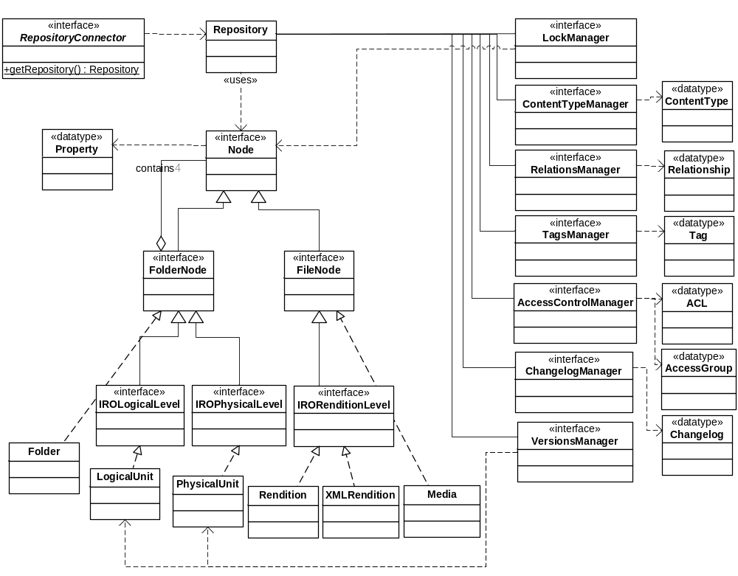
N.B: The above class diagram is not binding the implementation and is provided only as reference (e.g. the implementation may decide to implement the XML Rendition as a subclass of the Rendition class).

public interface RepositoryConnector
Connector to the repository.
Repository getRepository(Credentials user)
Attempts to establish a connection to a repository using the given parameters. The parameters must include the credentials for the user authentication.

public class Repository
Main Repository object. Provides access to the repository service managers.
Node getNodeByURI(java.lang.String URI)
Returns the node specified by the given URI. (See §13.1)
Node getNodeByUBI(java.lang.String UBI)
Returns the node specified by the given UBI. (See §13.1)
Node getRoot()
Alias for getNodebyURI("/")
boolean checkPermission(java.lang.String URI, PermissionEnum action)
Determines whether this Session has permission to perform the specified action at the specified URI.
boolean UBIexists (java.lang.String UBI)
Returns true if a node exists at the given UBI and connected user has read access to it; otherwise returns false.
boolean URIexists(java.lang.String URI)
Returns true if a node exists at the given URI and connected user has read access to it; otherwise returns false.
Node deleteNodeByURI(java.lang.String URI)
Delete the node specified by the given URI. Node removal constraints apply (See §5.1.4 and §5.2.6).
void delete(Node child)
Delete the given node. Node removal constraints apply (See §5.1.4 and §5.2.6).
ContentTypeManager getContentTypeManager()
Returns the Content-Type manager for the Repository.
LockManager getLockManager()
Returns the Lock manager for the Repository.
RelationsManager getRelationsManager()
Returns the Relationships manager for the Repository.
TagsManager getTagsManager()
Returns the Tags manager for the Repository.
VersionsManager getVersionsManager()
Returns the Versions manager for the Repository.
AccessControlManager getAccessControlManager()
Returns the access control manager for the Repository.
ChangelogManager getChangelogManager()
Returns the changelog manager for the Repository.
Transaction startTransaction(Node node)
Returns a transaction identifier if a transaction can be started for this node and/or any of its children (recursively); otherwise returns false. During the lifetime of the transaction the calling application has an exclusive lock on the affected nodes.
void endTransaction(Transaction task)
Ends the transaction. The affected nodes are unlocked.

public interface Node
Generic node, encapsulating the common functions for all fileable objects.
Property getSystemProperty(PropertyNameEnum name)
Gets the property of this node called name.
List<Property> getSystemProperties()
Returns a list with all the system properties for this node
void setSystemProperties(List<Property> values)
Sets the given properties of this node.
void setSystemProperty(Property value)
Sets the given property of this node.
Node getParent()
Returns the parent of this Node.
NodeIterator getLinkParents()
Returns a list of parents that contain links to this node.
Integer getOrder()
Returns the order of this node.
void setOrder(int newOrder)
Sets the new order of this node.
java.lang.String getURI()
Returns the URI to this node.
java.lang.String getName()
Returns the name of this node.
ObjectTypeEnum getTypeName()
Returns the object type name of this node (e.g. "File", "Folder", "Logical Unit", etc).
java.lang.String getLockOwner()
Returns the lock owner (username) of this node.
java.lang.String getCreator()
Returns the creator (username) of this node.
boolean isFolder()
Returns true if this node is a Folder.
boolean isLocked()
Returns true if this node is locked
boolean isLink()
Returns true if this node is a link child instance. False otherwise.
boolean isCheckedOut()
Returns true if this node is currently checked-out. False otherwise.
boolean isVersionPWC()
Returns true if this node is the private working copy. False otherwise.
boolean isLatest()
Returns true if this node is the latest version. False otherwise. For non versionable objects it returns true (default value).

public interface FolderNode
Extends: Node
Generic Folder object (See 4.1).
Node addChild(ObjectTypeEnum NodeTypeName, List<Property> NodeProperties)
Create a new Node of type NodeTypeName (File or Folder) as a child of this Folder. The new child takes the last position. Return the new Node object.
Node addChild(ObjectTypeEnum NodeTypeName, List<Property> NodeProperties, java.lang.integer orderId)
Create a new Node of type NodeTypeName as a child of this Folder taking the position of the given orderId. Return the new Node object.
void deleteChild(Node child)
Delete the given child from this Folder. Child's removal constraints apply (See §5.1.4 and §5.2.6).
void deleteChildbyName(java.lang.String name)
Delete the child with the given name from this Folder. Child's removal constraints apply (See §5.1.4 and §5.2.6).
void addLink(Node newChild)
Adds the newChild as a linked child of this Folder (See §5.1.7).
void addLink(Node newChild, java.lang.integer orderId)
Adds the newChild as a linked child of this Folder taking the position of the given orderId (See §5.1.7).
void deleteLink(Node Child)
Delete the link of this Child from this Folder (See §5.1.8 and 5.2.10).
void move(Node Child, Folder targetParent, java.lang.integer orderId)
Move the given Child to the targetParent at the given orderId position (See §5.1.9 and 5.2.11).
boolean hasChildren()
Returns true if this folder has children (including links).
NodeIterator getChildren(boolean latestVersion)
Return an ordered iterator over all the children under this Folder (See §5.1.10)
NodeIterator getChildrenByProperty(Property value, boolean latestVersion)
Return an iterator over all the children that have the same property value (See §5.1.10).
NodeIterator getChildrenByTag(Tag tag, boolean latestVersion)
Return an iterator over all the children that have the given tag (See §5.1.10).
NodeIterator search(Query criteria)
Return an iterator over all the nodes that satisfy the requested criteria (See §10). The search scope is defined by this Folder.

public interface FileNode
Extends: Node
Generic File object (See §4.2).
byte[] getData()
Gets the content-data of this File (See §5.2.3).
boolean setData(byte[] content)
Sets the content-data of this File (See §5.2.5).

public interface IROLogicalLevel
Extends: FolderNode
IRO Logical Level functionality
ContentProperty getContentProperty(java.lang.String name)
Gets the content property of this node called name.
List<ContentProperty> getContentProperties()
Returns all the logical-level content properties for the assosiated Content-Type of this node (See §6.2.1).
void setContentProperty(ContentProperty value)
Sets the given logical-level content property.
boolean isDocument()
Returns true if the node is a Logical Document.
boolean isInformationBlock()
Returns true if this node is a Logical Information Block.
boolean isChunk()
Returns true if this node is a Logical Chunk.
NodeIterator getLogicalUnits(boolean latestVersion)
Returns an iterator over all the Logical Units under this Logical Level.
NodeIterator getLanguages(boolean latestVersion)
Returns an iterator over all the Physical Units under this Logical Level.
boolean hasLanguage(java.lang.String languageCode)
Returns true if the Physical Unit for the given languageCode exists.
PhysicalUnit getLanguage(java.lang.String languageCode)
Returns the Physical Unit for the requested language code.
LogicalUnit addLogicalUnit(List<Property> LogicalUnitProperties)
Create a new Logical Unit of the given type (document, info. block or chunk) as a child of this one. Return the new LogicalUnit Object. The IRO containment rules apply.
LogicalUnit addLogicalUnit(List<Property> LogicalUnitProperties, java.lang.integer orderId)
Create a new FolderNode of the given type as a child of this one, taking the position of the given orderId. Return the new FolderNode object. The IRO containment rules apply.
PhysicalUnit addLanguage(java.lang.String languageCode, List<Property> PhysicalUnitProperties)
Create a new (empty) Physical Unit for the requested language.
PhysicalUnit addLanguage(java.lang.String languageCode, List<Property> PhysicalUnitProperties, byte[] XMLcontent)
Create a new Physical Unit including the given content as XML Rendition.
void deleteLanguage(java.lang.String languageCode)
Delete the Physical Unit of the given language. Removal constraints apply.

public interface IROPhysicalLevel
Extends: FolderNode
IRO Physical Level functionality
ContentProperty getContentProperty(java.lang.String name)
Gets the physical-level content property of this node called name.
List<ContentProperty> getAllContentProperties()
Returns all the physical-level content properties for the assosiated Content-Type of this node (See §6.2.1).
void setContentProperty(ContentProperty value)
Sets the given physical-level content property.
Rendition getRendition(java.lang.String name)
Returns the Rendition with the given name under this Physical Level.
NodeIterator getRenditions()
Return a list of all the Renditions under this Physical Level
Rendition addRendition(ObjectTypeEnum renditionType, List<Property> RenditionProperties, byte[] content)
Add the Rendition for this Physical Unit (the given "name" property shall not already exist under this physical unit).
void deleteRendition(java.lang.String name)
Delete the Rendition with the given name from this Physical Unit (removal constraints apply).
Media addMedia(List<Property> MediaProperties, byte[] media)
Add a new mediaFile under this Physical Level.
void deleteMedia(java.lang.String name)
Delete the Media with the given name.
NodeIterator getMedia()
Returns an iterator over all the media under this Physical Level.

public interface IRORenditionLevel
Extends: FileNode
IRO Rendition Level functionality
ContentProperty getContentProperty(java.lang.String name)
Gets the rendition-level content property of this node called name.
List<ContentProperty> getAllContentProperties()
Returns all the rendition-level content properties for the assosiated Content-Type of this node (See §6.2.1).
void setContentProperty(ContentProperty value)
Sets the given rendition-level content property.

public class Folder
Implements: FolderNode
Implementation of the FolderNode without versioning support.

public class LogicalUnit
Implements: IROLogicalLevel
IRO Logical Unit object (See §4.3).
void addLink(Node newChild)
Adds the newChild as a linked child of this Logical Unit respecting the IRO containment rules (See §5.3.2).
void addLink(Node newChild, java.lang.integer orderId)
Adds the newChild as a linked child of this Logical Unit respecting the IRO containment rules (See §5.3.2).
void move(Node Child, LogicalUnit target, java.lang.integer orderId)
Move the given Child to the target Folder, respecting the IRO containment rules (See §5.3.3).

public class PhysicalUnit
Implements: IROPhysicalLevel
IRO Physical Unit object (See §4.4).

public class Rendition
Implements: IRORenditionLevel
Rendition object (See §4.5).

public class XMLRendition
Implements: IRORenditionLevel
XML Rendition object (See §4.5.2).
byte[] updateXML(java.lang.String xpath, java.lang.String value)
Modifies the XML content setting the new value to the xpath. Returns the updated XML content (See §5.5.2).
XMLmetadata getXMLmetadata(java.lang.String name)
Returns the value of the requested rendition-level XML metadata (only for XML Renditions). (See §6.2.1).
List<XMLmetadata> getAllXMLmetadata()
Returns all the XML metadata that have been defined by the associated Content-Type. (See §6.2.3).

public class Media
Implements: FileNode
Media object (See §4.6).

public interface ContentTypeManager
Content-Type support methods
void defineContentType(ContentType type)
Defines (or updates) a Content-Type in the repository (See §6.1.1).
void undefineContentType(ContentType type)
Undefine the given Content-Type from the repository (See §6.1.2).
ContentType getContentTypeByName(java.lang.String name)
Return the Content-Type that has the given name (See §6.1.3).
List<ContentType> getAllContentTypes()
Return all the defined Content-Types (See §6.1.4).
void deleteXMLMetadata(String contentTypeName, String metadataName)
Deletes the XML metadata for the given property name and Content-Type name (See §6.1.5).

public interface LockManager
Locking support methods
void lock(Node node, boolean recursive)
Lock the given node. If recursive is true, run recursively.
void unlock(Node node, boolean recursive)
Unlock the given node. If recursive is true, run recursively.

public interface RelationsManager
Relationships support methods (See §7)
void defineRelationship(Relationship newrelation)
Creates or updates a relationship in the repository (See §7.1.1).
void undefineRelationship(Relationship relation)
Undefine the given relationship from the repository (See §7.1.2).
Relationship getRelationshipByName(java.lang.String name)
Return the relationship that has the given name (See §7.1.3).
List<Relationship> getAllRelationships()
Return all the defined relationships (See §7.1.4).
void relate(Node source, Node target, Relationship relation)
Relate the source and target nodes with the given relationship (See §7.2.1).
void deleteRelationship(Node source, Node target, Relationship relation)
Removes from the given relationship the given source and target nodes. (See §7.2.2)
NodeIterator getRelatedTargets(Relationship relation)
Return an iterator over the nodes that are targets for the given relationship.
NodeIterator getRelatedTargets(Relationship relation, Node node)
Return an iterator over the nodes that are targets for the given relationship and have as source the given node.
NodeIterator getRelatedSources(Relationship relation)
Return an iterator over the nodes that are sources for the given relationship.
NodeIterator getRelatedSources(Relationship relation, Node node)
Return an iterator over the nodes that are sources for the given relationship and have as source the given node.
List<Relationship> getSourceRelationships(Node node)
Return a list of relationships that the given node acts as source.
List<Relationship> getTargetRelationships(Node node)
Return a list of relationships that the given node acts as target.

public interface TagsManager
Tagging support methods (See §8)
void defineTag(Tag newtag)
Defines a new tag in the repository (See §8.1.1).
void undefineTag(Tag tag)
Undefine the given tag from the repository (See §8.1.2).
void updateTagDescription(Tag tag, java.lang.String description)
Update the description of the given tag.
Tag getTagbyName(java.lang.String name)
Return the tag that has the given name (See §8.1.3).
List<Tag> getAllTags()
Return all the defined tags (See §8.1.4).
List<Tag> getAllTags(Node node)
Return all the defined tags on the given node
void addTag(Node node, Tag tag)
Add the tag to the node (See §8.2.1).
void deleteTag(Node node, Tag tag)
Remove the tag from the node (See §8.2.2)

public interface VersionsManager
Versioning support methods (See §9)
NodeIterator getAllVersions(Node node)
Return an iterator over the versions of this node (See §9.1.1).
NodeIterator getMinorVersions(java.lang.integer major)
Return an iterator over the minor versions of this node under the given major version.
Node getLatestVersion(Node node)
Return the latest version of this node.
NodeIterator getVersionHistory(Node node)
Return an iterator over the parent versions of the given node using the "Based on" property (see §9.1.3).
Node checkOut(Node node, boolean major)
Checkout of the given node. The major flag defines if it is a major or minor version checkout. Return the PWC node (See §9.1.3).
Node checkOut(Node node, boolean major, List<Node> children)
Checkout of the given node. The major flag defines if it is a major or minor version checkout. Return the PWC node. The children list restricts the children to be copied under the private working copy (See §9.1.3).
Node checkIn(Node node)
Checkin the PWC of the given node. Return the new version.
void cancelCheckOut(Node node)
Cancel the checkout operation on the given node. (See §9.1.5)
Node getBasedOn(Node node)
Return the based on node of this node.

public interface AccessControlManager
ACL methods (See §11)
List<AccessControl> getAccessControlList(java.lang.String URI)
Returns the AccessControl objects that have been set to the node at the given URI or an empty array if no access control has been set.
List<AccessControl> getAccessControlList(Node node)
Returns the AccessControl objects that have been set to the node or an empty array if no access control has been set.
void addAccessControl(Node node, AccessControl aclEntry)
Adds the given aclEntry to the access control list of the node.
void setAccessControl(Node node, List<AccessControl> acl , boolean overwrite)
Sets the access control list of the node. If the overwrite parameter is "True", the ACL is overwritten. Otherwise, the current ACL is merged with the existing entries. The new entries take precedence over any conflicting existing entries.
void deleteAccessControl(Node node, AccessControl aclEntry)
Deletes the given aclEntry from the access control list of the node.
void defineGroup(Group group)
Defines a new Access Control Group. Returns true if the group is successfully defined.
void undefineGroup(Group group)
Undefines an Access Control Group. Returns true if the group is successfully undefined.
AccessGroup getGroupByName(java.util.String name)
Returns a Group entity of the given name.
List<AccessGroup> getAllGroups(java.util.String name)
Returns all groups.

public interface ChangelogManager
Changelog methods (See §12)
List<Changelog> getChangelogByURI(java.lang.Sring URI)
Returns a chronologically ordered list of all the changelog entries of all the objects under the given URI prefix. The number of changelog entries returned cannot exceed an upper limit (configuration parameter).
List<Changelog> getChangelogById(Long id)
Returns a chronologically ordered list of all the changelog entries related to the given object ID. The number of changelog entries returned cannot exceed an upper limit (configuration parameter).
List<Changelog> getChangelogByUBI(java.lang.String UBI)
Returns a chronologically ordered list of all the changelog entries related to the given UBI. The number of changelog entries returned cannot exceed an upper limit (configuration parameter).
List<Changelog> getChangelogByUser(java.lang.String URI, java.lang.String username)
Returns a chronologically ordered list of the changelog entries for the given username, under the given URI prefix. The number of changelog entries returned cannot exceed an upper limit (configuration parameter).
List<Changelog> getChangelogByAction(java.lang.String URI, java.lang.String action)
Returns a chronologically ordered list of the changelog entries for the given action, under the given URI prefix. The number of changelog entries returned cannot exceed an upper limit (configuration parameter).
List<Changelog> getChangelogByTime(java.lang.String URI, java.util.Date startDate, java.util.Date endDate)
Returns a chronologically ordered list of the changelog entries for the given time frame, under the given URI prefix. The number of changelog entries returned cannot exceed an upper limit (configuration parameter).
void changelogCleanup(java.util.Date endDate)
Removes all the changelog entries for the deleted nodes before the given timestamp and are already sent for notification.

Management Console

PURE-XML must have a management console (with web interface) that will allow users with "admin" permissions to execute all the repository management functions.
Those functions include:

- Read-write navigation to the repository's objects.
- Search interface
- Content-Type management (define / undefine Content-Types)
- Relationships management (define / undefine relationships)
- Tags management (define / undefine tags)
- ACL groups management
- Changelog search interface

The management console shall be considered as a client application. Only the Java binding of the API must be used for its implementation.

Use Cases
N.B. *** DRAFT ***

Create new Amendment
The sequence diagram below presents the process for the creation of a new amendment using the basic (CRUD) object functions of PURE-XML.

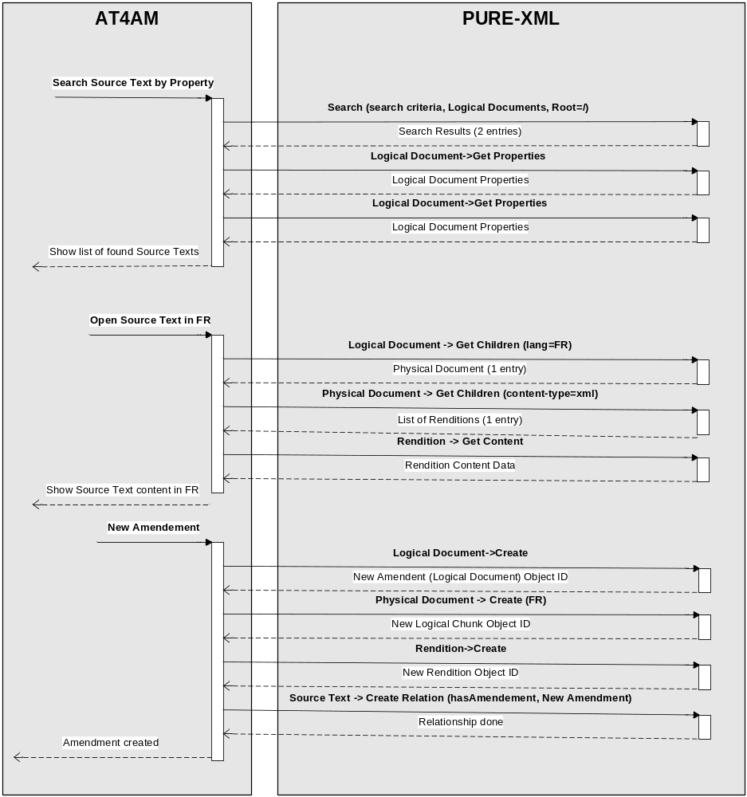

The user finds the document that he wants to amend and then creates the amendment (in this example for the FR language). We assume that the logical document and the amendment are located in the same Folder (business rule). In the above example the Source Text and its Amendment (Logical Documents) are stored as a single Logical Unit object.

Edit existing Amendment
The sequence diagram below presents the process for the editing of a new amendment using the versioning functions of PURE-XML.

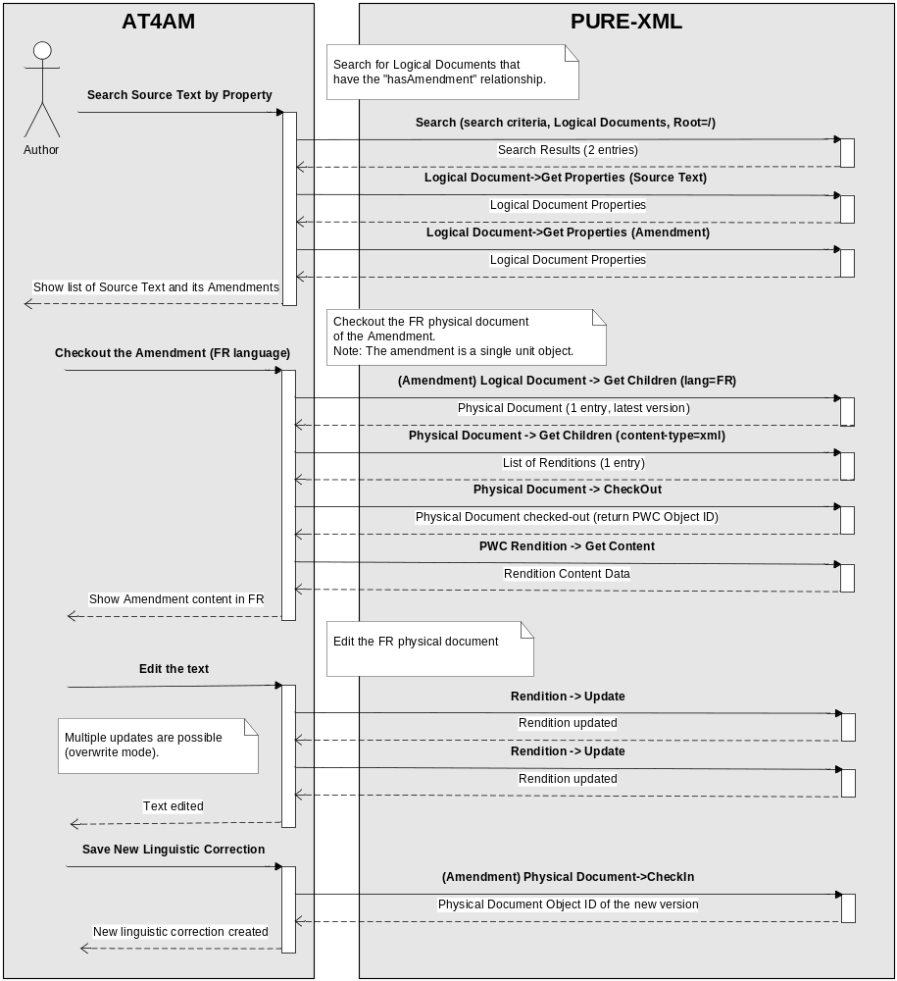
The user finds the amendment that he wants to edit and then checks-out the amendment (in this example for the FR language). For this use case, we assume that the amendment is a single unit. The user can save the text multiple times (without version increase) during the editing phase. The new version is created only when the check-in operation is executed.

Document Creation

The original Word documents will not be stored in PURE-XML.

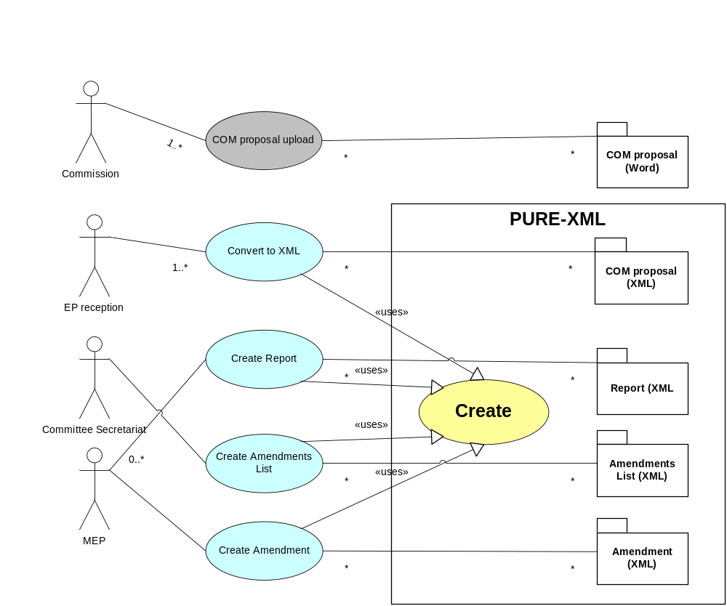

Permissions Table

Object | Function | Permission
Folder, File | Create | create
Folder, File | Get System Properties | read
Logical Unit  Physical Unit  XML Rendition | Get Content Properties | read
File | Get Content | read
Folder, File | Update System Properties | update
File | Update Content | update
XML Rendition | Update XML Content | update
Folder, File | Delete | delete
Folder, File | Lock | update
Folder, File | Unlock | update
Folder, File | Link | create
Folder, File | Unlink | delete
Folder, File | Move | create (target), delete (source)
Folder | Get Children | read
Folder, File | Get Versions | read
Folder, File | Get Latest | read
Folder, File | Get Active | read
Folder, File | Set Active | update
Folder, File | CheckOut | version
Folder, File | CheckIn | version
Folder, File | CancelCheckout | version
Folder, File | Create Relationship | relation
Folder, File | Delete Relationship | relation
Folder, File | Get Related Objects | read
Folder, File | Get Source Relationships | read
Folder, File | Get Target Relationships | read
Folder | Create Tag | update
Folder | Delete Tag | update
Folder, File | Get ACL | ACL
Folder, File | Set ACL | ACL
Folder | Search | read
Content-Type | Define Content-Type | admin
Content-Type | Undefine Content-Type | admin
Content-Type | Get Content-Type by name | read
Content-Type | Get All Content-Types | read
Content-Type | Delete XML Metadata | admin
Relationship | Define Relationship | admin
Relationship | Undefine Relationship | admin
Relationship | Get Relationship by name | read
Relationship | Get All Relationships | read
Tag | Define Tag | admin
Tag | Undefine Tag | admin
Tag | update Tag Description | admin
Tag | Get Tag by name | read
Tag | Get All Tags | read
AccessGroup | Define Group | admin
AccessGroup | Undefine Group | admin
AccessGroup | Get Group by name | ACL
AccessGroup | Get All Groups | ACL
Changelog | ChangeLog search | admin
Changelog | ChangeLog cleanup | admin

The language code is as defined in ISO 639-1 with the local EP extensions that are defined in CODICT (e.g. codes "xm" and "xl" for mixed-language and multiple-language text respectively).
The detailed definition of the reserved characters is in http://www.ietf.org/rfc/rfc3986.txt (URI Generic Syntax)
ISO 639-1 and local EP extensions (e.g. codes "xm" and "xl" for mixed-language and multiple-language text).
As defined in the STS document, system properties will be lazily loaded per node instance. Read permission check will also be executed once when the node instance is created. Get system properties function will not always return the latest values of the node’s system properties and may be deprecated after node retrieval.
The detailed definition of the reserved characters can be found at http://www.ietf.org/rfc/rfc3986.txt (URI Generic Syntax)
Property definition: Property name and value type. Unique constraint applies for the property name in a given level (Logical / Physical / Rendition).
XML metadata definition: Property name, value type, XPath expression and Text Path. Unique constraint applies for the property name.
The detailed definition of the reserved characters is in http://www.ietf.org/rfc/rfc3986.txt (URI Generic Syntax)
The detailed definition of the reserved characters is in http://www.ietf.org/rfc/rfc3986.txt (URI Generic Syntax)
The "Relevance" support is subject to the selected technical solution.
The value of the "Comment" field will be defined by the implementation.

